September 25, 2023
Office of Security and Public Safety

365 Fifth Avenue
New York, NY 10016-4309
212.817.7777
security@gc.cuny.edu
www.gc.cuny.edu

MEMORANDUM

TO: Andre Brown, University Director of Public Safety

FROM: John FIaherty, Director of Public Safety
SUBJECT: Presidential Approval Letter – CUNY School of Public Health & Health Policy

The attached document, the CUNY School of Public Health & Health Policy 2023 Annual Security Report, is completed and is being submitted to the U.S. Department of Education as required by law. This report includes crimes reported to Public Safety, Campus Security Authorities and data received from the local NYPD Precincts for 2020, 2021 and 2022. The report also contains University policies regarding the reporting of crimes, emergency notifications, timely warnings and other procedures including but not limited to all required information in compliance with Title IX. It has been prepared by my office and has been reviewed by the Office of University Public Safety. To the best of my knowledge and belief, it is a complete and accurate document. The attached report, absent any requested changes, will be published prior to October 1, 2023.

________________________________________________________ _____/______/______
John Flaherty, Director of Public Safety Date
I have reviewed the CUNY School of Public Health & Health Policy Annual Security Report as prepared by our Office of Public Safety.

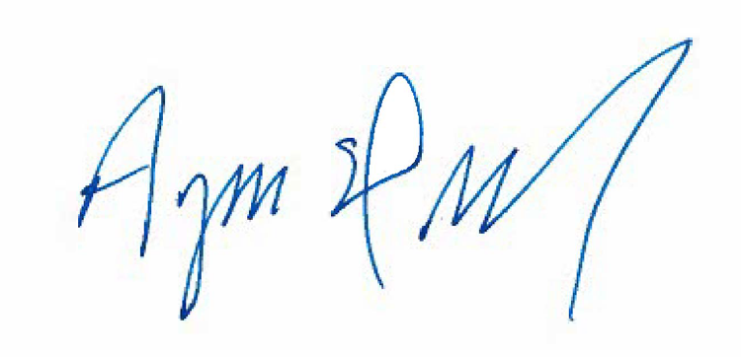
________________________________________________________ ___09/_25___/23____
Dean Ayman El-Mohandes Date

