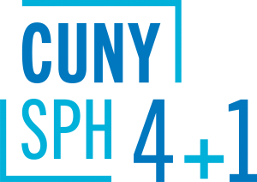
Course Sequences
Master of Science (MS)
in Population Health Informatics
The optional course sequences below are designed for full-time students who plan to complete the 4+1 program in five years. Part-time students are encouraged to meet with a staff advisor to map out an appropriate plan of study.
__________________________________________________________________
4+1 students starting summer of junior year:
Semester | Course
Year 1 | Undergraduate coursework
Year 2 | Undergraduate coursework
Year 3 | Summer semester: PUBH 611  Fall semester: PUBH 601, PUBH 613  Spring semester: PUBH 614, EPID 631
Year 4 | Fall semester: EPID 630  Spring semester: EPID 633
Year 5  (SPH matriculate) | Summer semester: PUBH 610, PUBH 612  Fall semester: EPID 632, EPID 634, EPID 635  Spring semester: EPID 700
4+1 students starting fall of junior year:
Semester | Course
Year 1 | Undergraduate coursework
Year 2 | Undergraduate coursework
Year 3 | Fall semester: PUBH 601, PUBH 611  Spring semester: PUBH 613, EPID 631
Year 4 | Fall semester: PUBH 614, EPID 630  Spring semester: EPID 633
Year 5  (SPH matriculate) | Summer semester: PUBH 610, PUBH 612  Fall semester: EPID 632, EPID 634, EPID 635  Spring semester: EPID 700
4+1 students starting spring of junior year:
Semester | Course
Year 1 | Undergraduate coursework
Year 2 | Undergraduate coursework
Year 3 | Fall semester: Undergraduate coursework  Spring semester: PUBH 601, PUBH 611, PUBH 613
Year 4 | Fall semester: PUBH 614, EPID 630  Spring semester: EPID 631, EPID 633
Year 5  (SPH matriculate) | Summer semester: PUBH 610, PUBH 612  Fall semester: EPID 632, EPID 634, EPID 635  Spring semester: EPID 700

