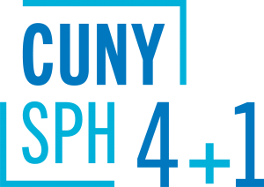
Course Sequences
Master of Science (MS)
in Health Communication for Social Change
The optional course sequences below are designed for full-time students who plan to complete the 4+1 program in five years. Part-time students are encouraged to meet with a staff advisor to map out an appropriate plan of study.
__________________________________________________________________
4+1 students starting summer of junior year:
Semester | Course
Year 1 | Undergraduate coursework
Year 2 | Undergraduate coursework
Year 3 | Summer semester: PUBH 611  Fall semester: PUBH 601, PUBH 613  Spring semester: PUBH 614, CHSS 628
Year 4 | Fall semester: CHSS 626  Spring semester: CHSS 627
Year 5  (SPH matriculate) | Summer semester: PUBH 610, PUBH 612  Fall semester: CHSS 629, CHSS 630, Elective I  Spring semester: CHSS 700
4+1 students starting fall of junior year:
Semester | Course
Year 1 | Undergraduate coursework
Year 2 | Undergraduate coursework
Year 3 | Fall semester: PUBH 601, PUBH 611  Spring semester: PUBH 613, CHSS 628
Year 4 | Fall semester: PUBH 614, CHSS 626  Spring semester: CHSS 627
Year 5  (SPH matriculate) | Summer semester: PUBH 610, PUBH 612  Fall semester: CHSS 629, CHSS 630, Elective I  Spring semester: CHSS 700
4+1 students starting spring of junior year:
Semester | Course
Year 1 | Undergraduate coursework
Year 2 | Undergraduate coursework
Year 3 | Fall semester: Undergraduate coursework  Spring semester: PUBH 601, PUBH 611, PUBH 613
Year 4 | Fall semester: PUBH 614, CHSS 626  Spring semester: CHSS 627, CHSS 628
Year 5  (SPH matriculate) | Summer semester: PUBH 610, PUBH 612  Fall semester: CHSS 629, CHSS 630, Elective I  Spring semester: CHSS 700

