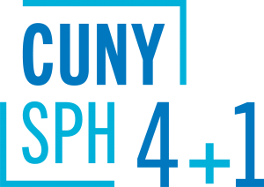
Course Sequences
Master of Science (MS)
in Global & Migrant Health Policy
The optional course sequences below are designed for full-time students who plan to complete the 4+1 program in five years. Part-time students are encouraged to meet with a staff advisor to map out an appropriate plan of study.
__________________________________________________________________
4+1 students starting summer of junior year:
Semester | Course
Year 1 | Undergraduate coursework
Year 2 | Undergraduate coursework
Year 3 | Summer semester: PUBH 613  Fall semester: PUBH 601, PUBH 614  Spring semester: HPAM 621, HPAM 623
Year 4 | Fall semester: HPAM 626  Spring semester: HPAM 628
Year 5  (SPH matriculate) | Fall semester: HPAM 627, HPAM 629, Elective I  Spring semester: PUBH 698, Elective II
4+1 students starting fall of junior year:
Semester | Course
Year 1 | Undergraduate coursework
Year 2 | Undergraduate coursework
Year 3 | Fall semester: PUBH 601, PUBH 613  Spring semester: PUBH 614, HPAM 623
Year 4 | Fall semester: HPAM 626  Spring semester: HPAM 621, HPAM 628
Year 5  (SPH matriculate) | Fall semester: HPAM 627, HPAM 629, Elective I  Spring semester: PUBH 698, Elective II
4+1 students starting spring of junior year:
Semester | Course
Year 1 | Undergraduate coursework
Year 2 | Undergraduate coursework
Year 3 | Fall semester: Undergraduate coursework  Spring semester: PUBH 601, PUBH 613
Year 4 | Fall semester: PUBH 614, HPAM 626  Spring semester: HPAM 621, HPAM 623, HPAM 628
Year 5  (SPH matriculate) | Fall semester: HPAM 627, HPAM 629, Elective I  Spring semester: PUBH 698, Elective II

