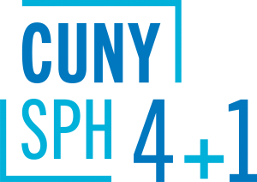
Course Sequences
Master of Science (MS)
in Environmental & Occupational Health Sciences
The optional course sequences below are designed for full-time students who plan to complete the 4+1 program in five years. Part-time students are encouraged to meet with a staff advisor to map out an appropriate plan of study.
__________________________________________________________________
4+1 students starting summer of junior year:
Semester | Course
Year 1 | Undergraduate coursework
Year 2 | Undergraduate coursework
Year 3 | Summer semester: PUBH 613  Fall semester: PUBH 601, PUBH 614  Spring semester: EOHS 626, EOHS 643
Year 4 | Fall semester: EOHS 633  Spring semester: EOHS 622
Year 5  (SPH matriculate) | Fall semester: EOHS 623, EOHS 625, EOHS 627, Elective I  Spring semester: PUBH 698, Elective II, Elective III
4+1 students starting fall of junior year:
Semester | Course
Year 1 | Undergraduate coursework
Year 2 | Undergraduate coursework
Year 3 | Fall semester: PUBH 601, PUBH 613  Spring semester: PUBH 614, EOHS 626
Year 4 | Fall semester: EOHS 633, EOHS 623  Spring semester: EOHS 622
Year 5  (SPH matriculate) | Fall semester: EOHS 625, EOHS 627, EOHS 643, Elective I  Spring semester: PUBH 698, Elective II, Elective III
4+1 students starting spring of junior year:
Semester | Course
Year 1 | Undergraduate coursework
Year 2 | Undergraduate coursework
Year 3 | Fall semester: Undergraduate coursework  Spring semester: PUBH 601, PUBH 613, EOHS 626
Year 4 | Fall semester: PUBH 614, EOHS 633  Spring semester: EOHS 622, EOHS 643
Year 5  (SPH matriculate) | Fall semester: EOHS 625, EOHS 623, EOHS 627, Elective I  Spring semester: PUBH 698, Elective II, Elective III

