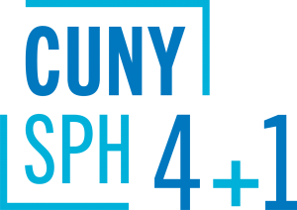
Course Sequences
Master of Public Health (MPH)
in Epidemiology & Biostatistics
The optional course sequences below are designed for full-time students who plan to complete the 4+1 program in five years. Part-time students are encouraged to meet with a staff advisor to map out an appropriate plan of study.
__________________________________________________________________
4+1 students starting summer of junior year:
Semester | Course
Year 1 | Undergraduate coursework
Year 2 | Undergraduate coursework
Year 3 | Summer semester: PUBH 610  Fall semester: PUBH 613, PUBH 601  Spring semester: PUBH 611, PUBH 614
Year 4 | Fall semester: PUBH 612  Spring semester: Elective I
Year 5  (SPH matriculate) | Summer semester: BIOS 620, EPID 620  Fall semester: PUBH 696, BIOS 621, EPID 621, Elective II  Spring semester: PUBH 698, EPID 622
4+1 students starting fall of junior year:
Semester | Course
Year 1 | Undergraduate coursework
Year 2 | Undergraduate coursework
Year 3 | Fall semester: PUBH 613, PUBH 614  Spring semester: PUBH 610, PUBH 611
Year 4 | Fall semester: PUBH 612  Spring semester: PUBH 601
Year 5  (SPH matriculate) | Summer semester: BIOS 620, EPID 620  Fall semester: PUBH 696, BIOS 621, EPID 621, Elective I  Spring semester: PUBH 698, EPID 622, Elective I
4+1 students starting spring of junior year:
Semester | Course
Year 1 | Undergraduate coursework
Year 2 | Undergraduate coursework
Year 3 | Fall semester: Undergraduate coursework  Spring semester: PUBH 601, PUBH 613, PUBH 614
Year 4 | Fall semester: PUBH 610, PUBH 611  Spring semester: PUBH 612
Year 5  (SPH matriculate) | Summer semester: BIOS 620, EPID 620  Fall semester: PUBH 696, BIOS 621, EPID 621, Elective I  Spring semester: PUBH 698, EPID 622, Elective II

