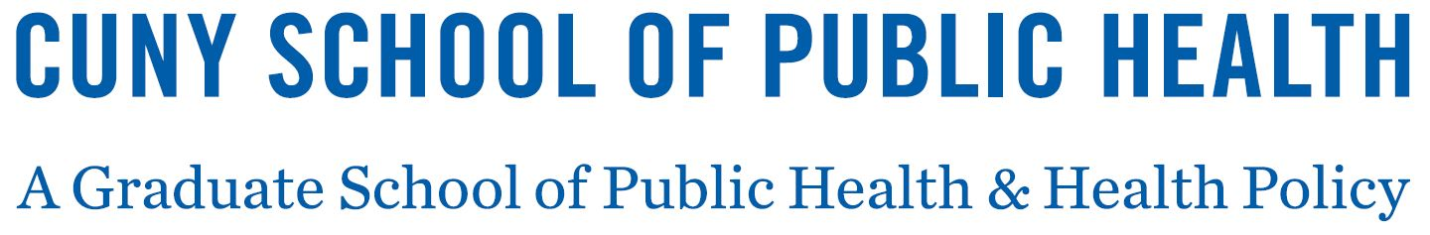

MENINGOCOCCAL VACCINATION RESPONSE FORM

New York State Public Health Law requires that all college and university students enrolled for at least six (6) semester hours or the equivalent per semester, or at least four (4) semester hours per quarter, complete and return the following form to [enter name of college/university health center].

Check one box and sign below.

I have (for students under the age of 18: My child has):

□ had meningococcal immunization within the past 5 years. The vaccine record is attached.

[Note: The Advisory Committee on Immunization Practices recommends that all first-year college students up to age 21 years should have at least 1 dose of Meningococcal ACWY vaccine not more than 5 years before enrollment, preferably on or after their 16th birthday, and that young adults aged 16 through 23 years may choose to receive the Meningococcal B vaccine series. College and university students should discuss the Meningococcal B vaccine with a healthcare provider.]

□ read, or have had explained to me, the information regarding meningococcal disease. I (my child) will obtain immunization against meningococcal disease within 30 days from my private health care provider or [ENTER NAME OF COLLEGE HEALTH CENTER OR OTHER HEALTH FACILITY].

□ read, or have had explained to me, the information regarding meningococcal disease. I understand the risks of not receiving the vaccine. I have decided that I (my child) will not obtain immunization against meningococcal disease.

Signed Date
(Parent / Guardian if student is a minor)

Print Student’s name Student / /
Date of Birth
Student
E-mail address Student ID#

Student
Mailing Address

Student
Phone number ( )

