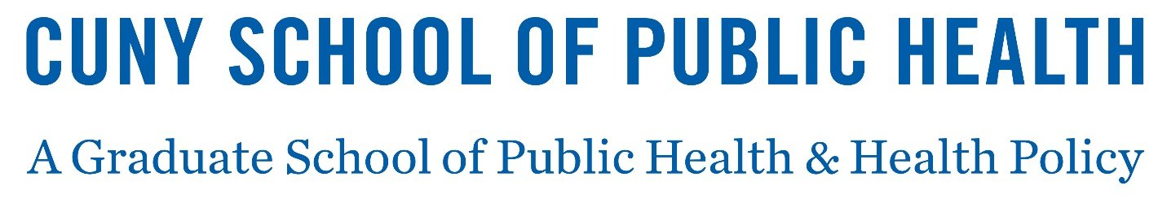
Tuition Refund Policy
A student is entitled to a full refund of tuition and non-instructional fees (where applicable) in the event that courses are eliminated or a student's registration is cancelled by the CUNY Graduate School of Public Health and Health Policy.
For students who wish to drop a course, a proportionate refund of tuition may be made as outlined below and can be found within the Academic Calendar. This excludes non-refundable application fees and any mandatory fees. Refund will be made in the form of initial payment.
If you drop a course(s):
- 100% refund - drop before the official first day of classes for the semester
- 75% refund - drop within one week of the official first day of classes for the semester
- 50% refund - drop within two weeks of the official first day of classes for the semester
- 25% refund - drop within three weeks of the official first day of classes for the semester
- Refunds are not issued for official withdrawals (W grades), unofficial withdrawals (WU, WN grades), no-credits (NC grades) and failing grades (F grades). These occur after the third week of the official first day of classes for the semester
- Student who are enrolled full-time and drop to part-time after the first official day of classes (per the schedule above) pay the full-time rate.
- Refunds are automatically applied towards any outstanding tuition and fee balances.
This schedule is not applicable to withdrawals due to the military, Peace Corps, or leaves for other national service, and is subject to change by action of the Board of Trustees of The City University of New York (CUNY). If any of the above circumstances are the basis for your withdrawal, please contact the Registrar or email registrar@sph.cuny.edu.

