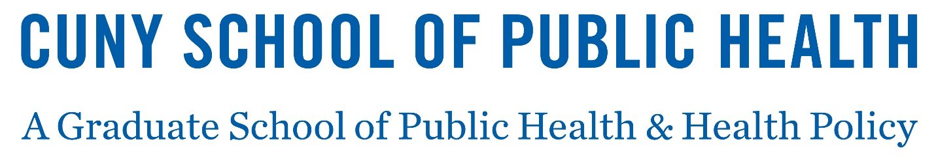
COMMITMENT DEPOSIT FORM
To reserve your space at the CUNY Graduate School of Public Health and Health Policy, you are required to submit a non-refundable, $250 (USD) commitment deposit.
This deposit will be credited towards your tuition charge on your first semester’s bill. It will also reserve your seat in the program you applied to and enable you to register for classes.
The deadline for submission of this commitment deposit is three weeks from the date of your admission letter.
Please mail your check or money order in the amount of $250 (USD only) made payable to The CUNY Graduate School of Public Health and Health Policy along with the bottom of your this form to:
CUNY Graduate School of Public Health & Health Policy
Office of Student and Alumni Services
55 W. 125th Street, Room 721
New York, NY 10027 USA

Please remember to sign and date the bottom of the Commitment Deposit Form.

There will be a $20 fee for all returned payments.

Please print this form and return this portion of the page with your payment.
Term: Fall
Student Name:
Student’s Sophas ID:
Student’s Street Address:
Student’s City, State & Zip Code:
Student’s Country:
Student’s Signature: Date:
--------------------------------------------------------------------------------------------------------------------------------------
For SPH Staff ONLY
Check/Money Order #: Check/Money Date:

